int_bazaarvoice

Version 5.2



Summary

This document provides technical instructions for installing the Demandware Integration LINK integration that lets you integrate Bazaarvoice (BV) solutions with a Demandware storefront. This document is intended for individuals who possess at least a general understanding of the following topics:

  - Web development
  - Demandware UX Studio integrated development environment (IDE)
  - Bazaarvoice Ratings & Reviews (R&R), Ask & Answer (A&A), or Stories
  - Interface components

Component Overview

Functional Overview

The Demandware LINK integration supports the following Bazaarvoice (BV) feature set:

- Ratings & Reviews
  - Submission (including login integration)
  - Display
  - Inline Ratings on Category & Search Results pages
  - Post-Interaction Email (PIE)
  - SmartSEO Basic & SmartSEO Advanced Inline-paging
- Ask & Answer
  - Submission (including login integration)
  - Display
  - Integration at Product Page & Category Page levels
  - SmartSEO Basic & SmartSEO Advanced Inline-paging
- Stories
  - Submission (including login integration)
  - Display
  - Integration at Product Page & Category Page levels
  - SmartSEO Basic & SmartSEO Advanced Inline-paging

NOTE: As of April, 2012, Bazaarvoice deprecated support for the Active Profiles product. The Demandware LINK cartridge may contain references to support Active Profiles. These references should be ignored. No attempt should be made to implement Active Profiles using the LINK cartridge.

The Demandware LINK Integration, which is also referred to as the Bazaarvoice (BV) cartridge, provides the following integration points with Bazaarvoice (BV) solutions:

- Demandware Storefront functionality
  - Ratings & Reviews (R&R)
  - Ask & Answer (A&A)
  - Stories

- For storefront functionality to work properly, the following integration would be set up in business manager
  - Product export feed generation
  - Inline ratings feed consumption
  - Smart SEO feed consumption
  - Mobile Smart Display for R&R display and submission
  - Post-Interaction-Email (PID) feed generation

Use Cases

- Ratings & Reviews
List the use cases and appropriate action take listed below:
Use Case Scenarios | Result
The merchant implement Ratings and Reviews service from BV | User will be able to read/write ratings and reviews on product pages, and view inline ratings on category pages and search result pages.

- Ask & Answer
List the use cases and appropriate action take listed below:
Use Case Scenarios | Result
The merchant implement Ask and Answer content service from BV | User will be able to read/write Ask and Answer content on product page and category pages (optional).

- Stories
List the use cases and appropriate action take listed below:
Use Case Scenarios | Result
The merchant implement Stories service from BV | User will be able to read/write Stories content on product pages and category pages (optional).

Limitations, Constraints

Use of the Bazaarvoice Demandware LINK cartridge by itself does not grant nor enable use of the Bazaarvoice offerings (e.g. Ratings & Reviews, etc.). Bazaarvoice must separately enable the hosted Bazaarvoice SAAS services for the offerings to available on the Demandware platform. This may require a separate agreement with Bazaarvoice. Contact Bazaarvoice for details.

Compatibility

Compatible Site Genesis version 10.6

Privacy, Payment

Customer will create a display name when leaving a review. The display name will be seen to public. Bazaarvoice does not access or display any other customer profile information.
The Bazaarvoice LINK cartridge itself is available free of charge. See “Limitations, Constraints” section for details regarding potential costs involved with enabling the Bazaarvoice hosted SAAS offerings.

Implementation Guide

Prerequisites

Enabling Bazaarvoice Hosted Services
A Bazaarvoice representative must enable the hosted services for the desired
Bazaarvoice products (e.g. Ratings & Reviews, Ask & Answer, and Stories).

Bazaarvoice will complete tasks such as the following:

- Setup instance of BV hosted services
- Provide client-specific settings such as BV SFTP credentials, Hostname, Display Code, etc. to be used in the Custom Site Preferences (see section 5.1)
- Enable processes for BV to consume product catalog and order feeds generated by the LINK integration
- Enable outbound SmartSEO and Inline Ratings feeds to be consumed by the LINK integration
- Enable and configure specific features for each desired BV product
- Style the hosted visual display and submission elements

Setup

Bazaarvoice’s LINK integration uses the following cartridges:
- int_bazaarvoice – This cartridge contains all of the pipelines, templates and scripts to display and create R&R, A&A, stories and active profile. Also included pipelines to run as jobs managing feeds generates, import and export
- SiteGenesis_Sample – This cartridge contains altered templates for referencing in integration

Configuration

Installation and configuration instructions can be found at http://developer.bazaarvoice.com/demandwarehelp/index.html.

Custom Code

The included sample cartridge, “SiteGenesis_Sample”, includes any changes that would need to be made assuming you are using the Site Genesis reference storefront.

Templates
- pt_productdetail.isml
- product.isml
- productsearchhittile.isml
- pt_productsearchresult.isml
Resource
- product.properties

Instructions for completing these changes can be found at:
http://developer.bazaarvoice.com/demandwarehelp/index.html.

External Interfaces

A subdomain that is used for all user-facing URLs – including submission URLs, deep-linking URLs, and links to landing pages – must point to Bazaarvoice servers. All implementations requires are in 3.2 DNS Configuration.

Testing

To view an un-styled demonstration of Bazaarvoice R&R, A&A, and Stories integrated with the Demandware Site Genesis Storefront, visit the following site:

http://bazaarvoice01.tech-prtnr-na01.dw.demandware.net/on/demandware.store/Sites-SiteGenesis-Site

Operations, Maintenance

Data Storage

The export and import feeds will be stored under webdav/Sites/Temp while the jobs are running and deleted when the jobs finished. There will not be feeds storage on Impex.

Availability

BV hosted services perform with an uptime of 99.9% reliability. Additionally, the Bazaarvoice services are designed in such a way to gracefully fail without impact on the Demandware webstore performance. If the event of failure, Bazaarvoice functionality will simply cease to exist on the target pages.

Support

Contact partner-support@bazaarvoice.com regarding this LINK cartridge.

User Guide

Roles, Responsibilities

Recursive jobs should be scheduled to run in daily basis. Before running each job, make sure the feeds are turned on in site preferences group.

- Product Feed Export
- PurchaseData Feed Export
- Inline Rating Feed Import
- SmartSEO Feed Import

Installation and configuration instructions can be found at http://developer.bazaarvoice.com/demandwarehelp/index.html.

Business Manager

Bazaarvoice Custom Site Preference Groups for Bazaarvoice consist of the following:
Site > Site Preferences > Custom Preferences

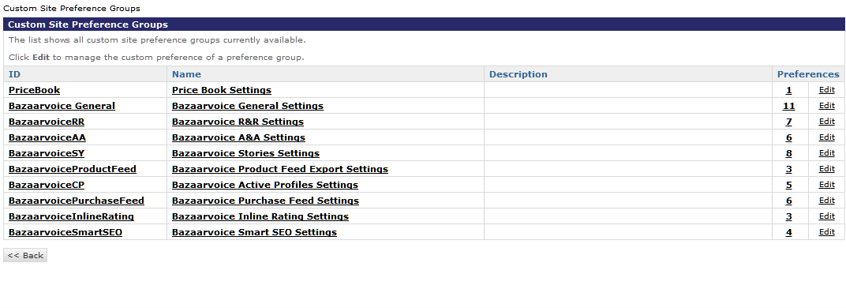
Image: Custom Site Preference Groups

- Bazaarvoice General
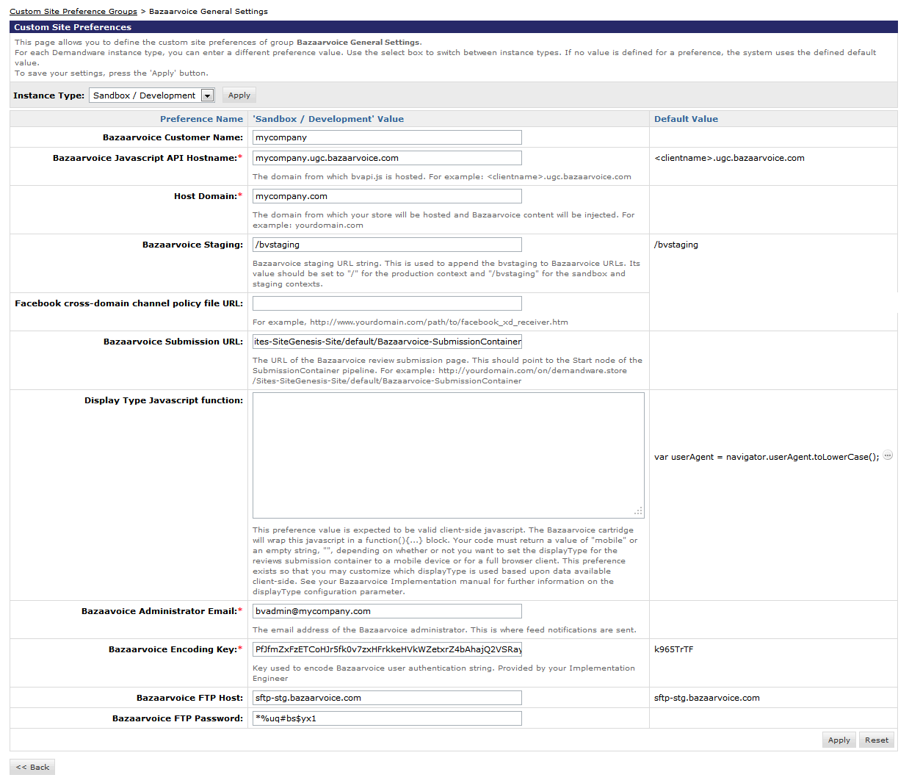Image: Bazaarvoice General Settings
- BazaarvoiceRR
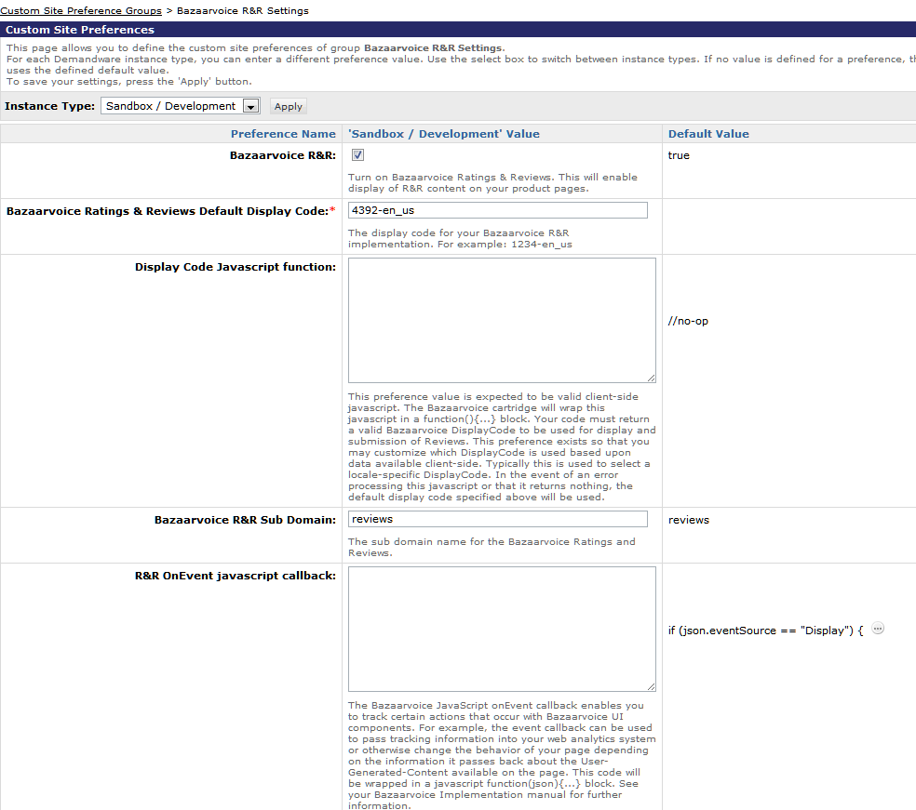
Image: Bazaarvoice Rating & Reviews Settings
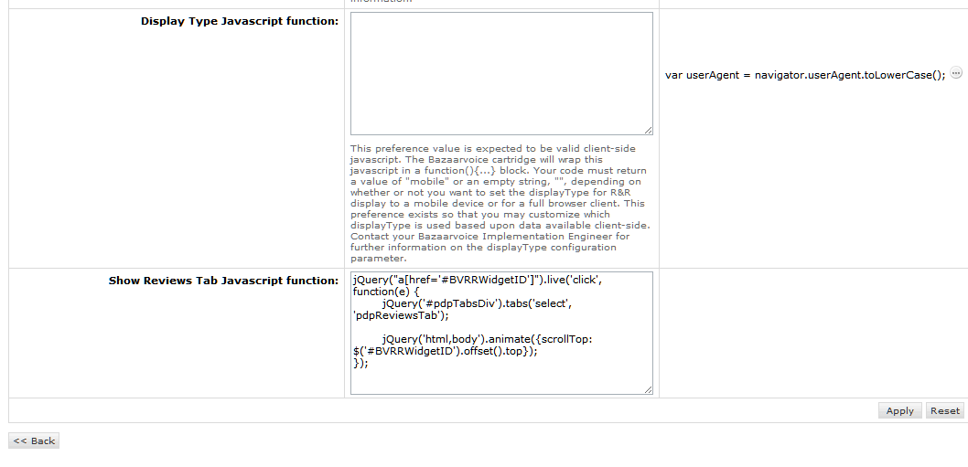
Image: Bazaarvoice Rating & Reviews Settings (cont.)
- BazaarvoiceAA
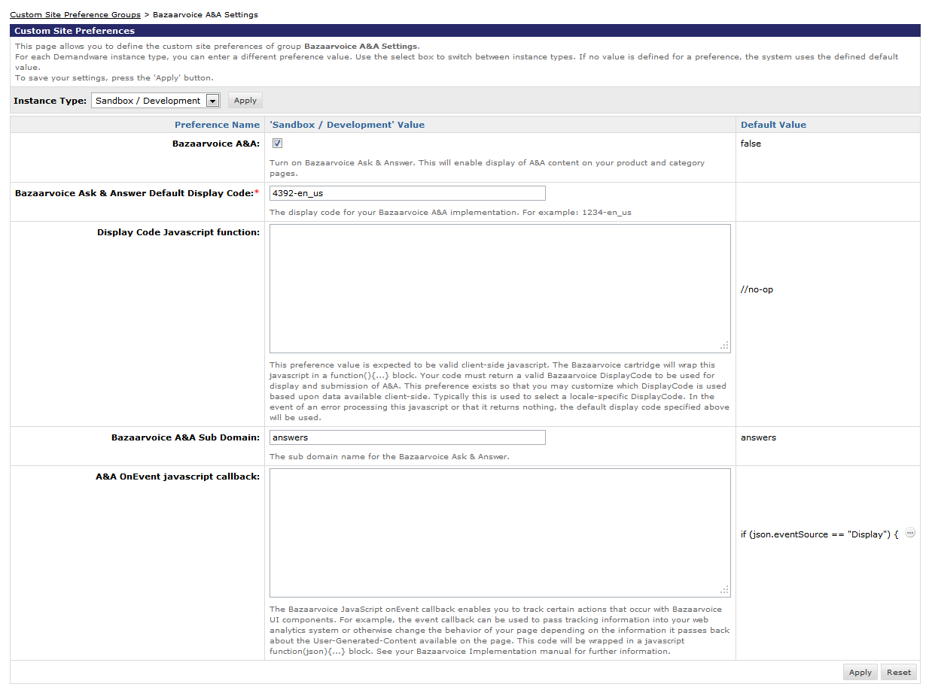
Image: Bazaarvoice Ask & Answer Settings
- BazaarvoiceSY
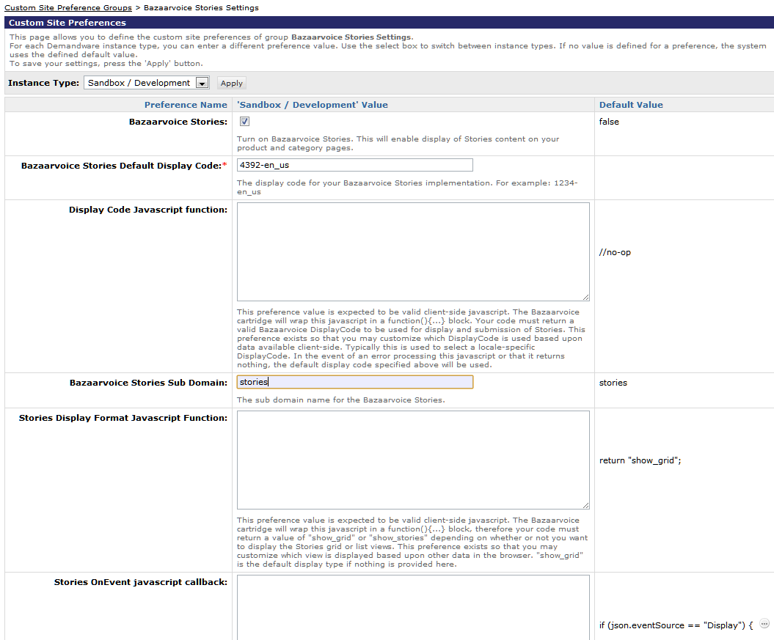
Image: Bazaarvoice Stories Settings
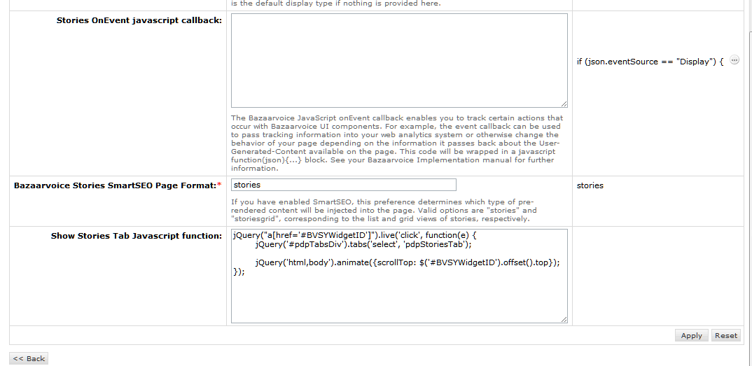
Image: Bazaarvoice Stories Settings (cont.)
- BazaarvoiceProductFeed
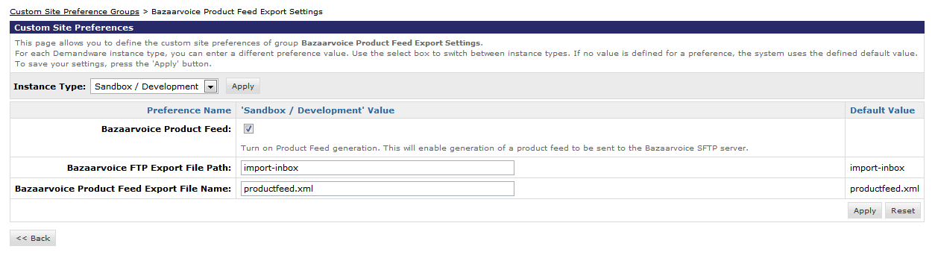
Image: Bazaarvoice Product Feed Export Settings
- BazaarvoiceCP (NOTE: These preferences are for the “Active Profiles” feature/product. This feature has been deprecated by Bazaarvoice. Do not use these preferences.)
- BazaarvoicePurchaseFeed
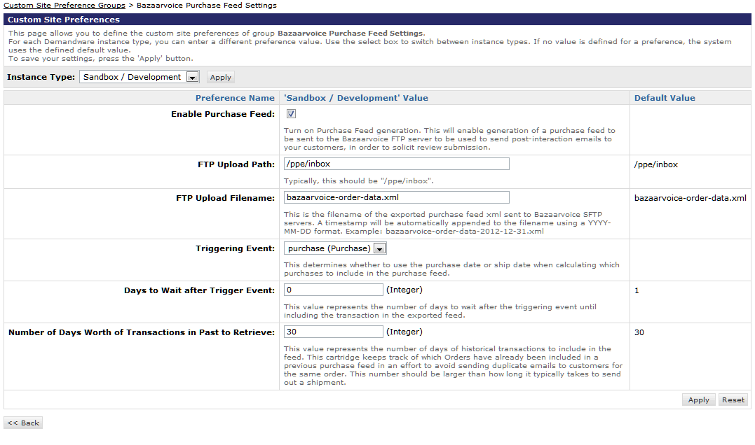
Image: Bazaarvoice Purchase Feed settings
- BazaarvoiceInlineRating
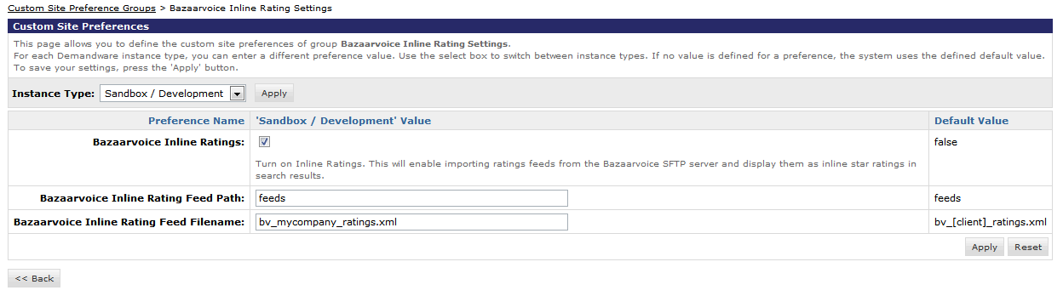
Image: Bazaarvoice Inline Ratings Settings
- BazaarvoiceSmartSEO
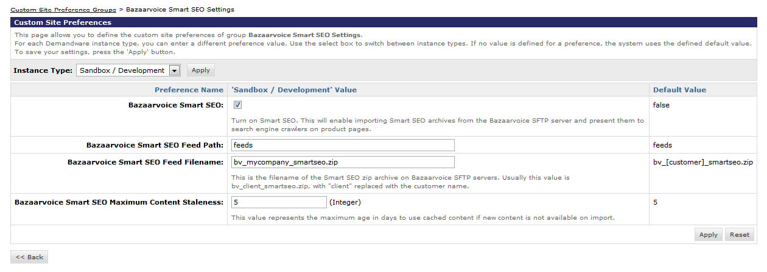
Image: Bazaarvoice SmartSEO settings

Storefront Functionality

Inline Ratings (Category, Search Results pages):

When using the inline rating for search result and/or category pages, after the importInlinerating feed success, you should be able to see the appropriate star rating image, average rating statistic, and rating count statistic for each product displayed on the search result and/or category page.

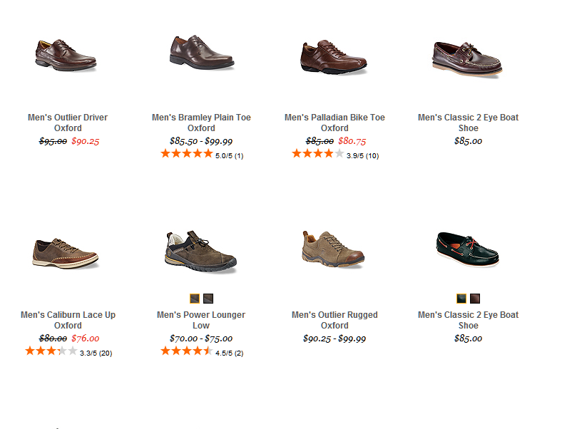
Product Page:

When the product page template has been updated to include the Bazaarvoice DIV tags, you should be able to see the ratings and reviews, ask and answers (if applicable), and stories (if applicable) on the product page.

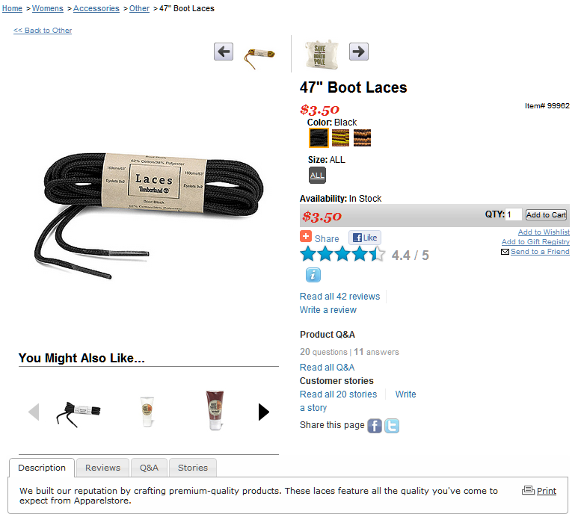

The “Write a review link” will take you to the submission link that you defined in site preference.

All of the templates that handle the display of Bazaarvoice data reside in the
default/bv/display subdirectory of the templates directory. All of the templates that handle
the submission of Bazaarvoice data reside in the default/bv/submit subdirectory of the
templates directory.

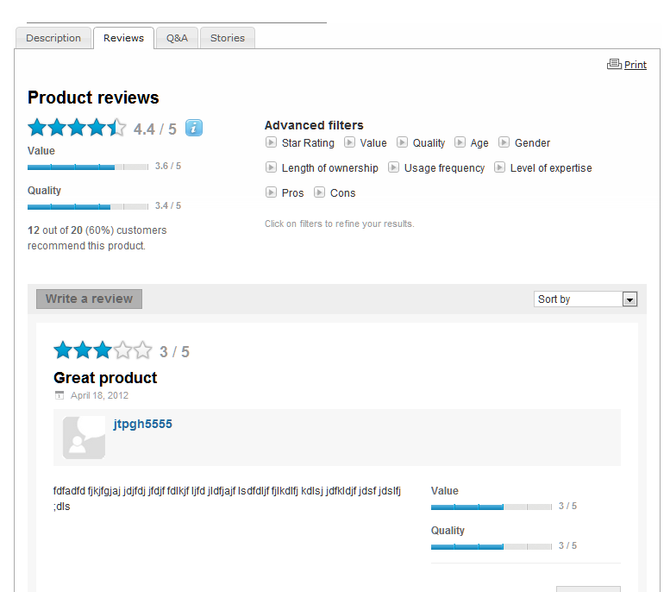
Submission Container Integration Templates

The Bazaarvoice products R&R, A&A, and Stories share the same submission container. All submission templates are referenced from within the Bazaarvoice templates, so you do not need to include them elsewhere in the storefront. The file submissioncontainer.isml renders the page that contains the submission form.

All of the logic that handles user authentication and that redirects the user to and from the login page is handled within the Bazaarvoice pipeline. The following URL provides an example of a URL that points toward the generic submission container.

.../on/demandware.store/Sites-SiteGenesis-Site/default/Bazaarvoice- SubmissionContainer

Known Issues

Release History

Version | Date | Changes
5.1.1 |  | - Quota violation fix for plugin version 5.1  - Included functionality to open tab on PDP when clicking “read all reviews” (analogous fixes for displaying Ask & Answer and Stories content behind tabs)  - Removed default value for “Bazaarvoice Encoding Key” preference  - Removed global preference for bvdisplaycode (no longer used)  - Timestamp automatically appended to Order Feed XML filename  - Ratings statistics set to zero for all products prior to new statistic values being imported from XML ratings feed
5.2 |  | - Support for multi-locale DW sites integrating with single BV instance  - Additional data elements in product catalog feed for BV network functionality  - Support for configurable image sizes in product catalog and orders feed generation processes  - Remove issue with incorrect display on Search Results pages

? int_bazaarvoice, version 5.2

